**COMPUTER NETWORKS**

**NAME: M.ISTAFA MALIK**

**ROLL: P190033**

**SECTION: BSCS-5A**

**Task 1:**

**Solution:**

Open Command Prompt and simply type ipconfig.

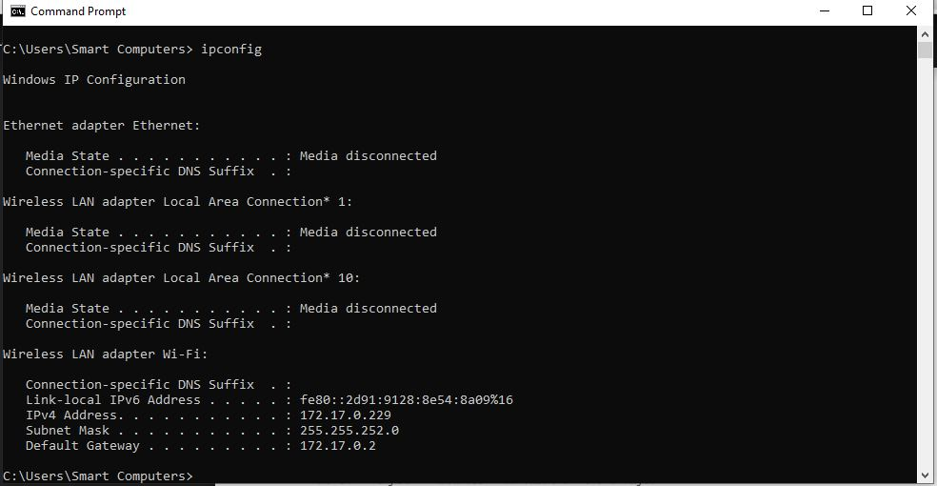

IPv4 Address……………………172.17.0.229

Subnet Mask……………………255.255.252.0

Default Gateway………………172.17.0.2

**Task 2:**

**Solution:**

IPv4 Address………………….172.17.1.247

IPv4 Address………………….172.17.1.155

IPv4 Address………………….172.17.1.189

**Task 3:**

**Solution:**

1:

* Open Command Prompt and simply type ipconfig.



2:

* Open System Information
* Click on components
* Click on Network
* Click on adaptors

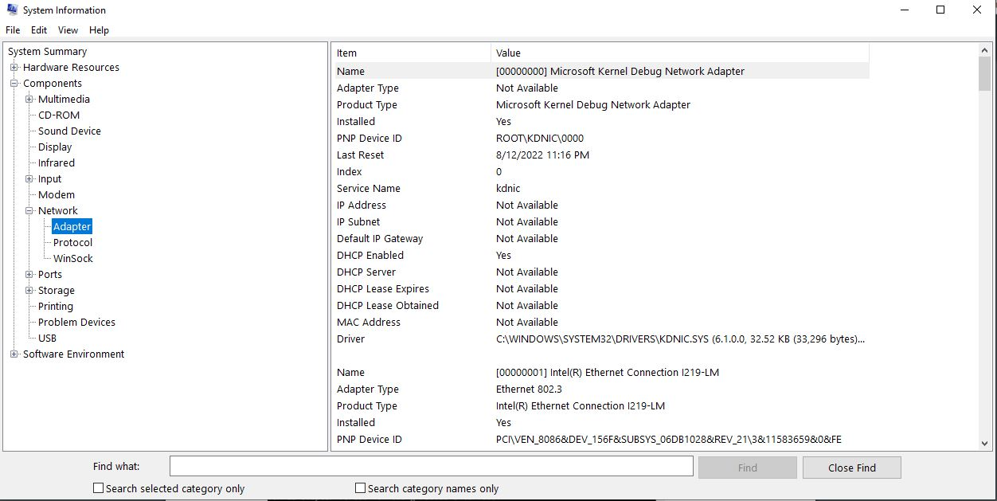

3:

* Open Task manager using right click on bottom bar
* Then click on performance
* Then click on Wifi

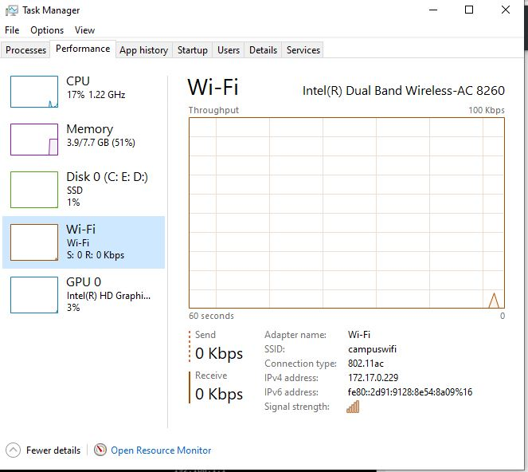

4:

* Click on your Network setting
* Open properties of your connected device or wifi

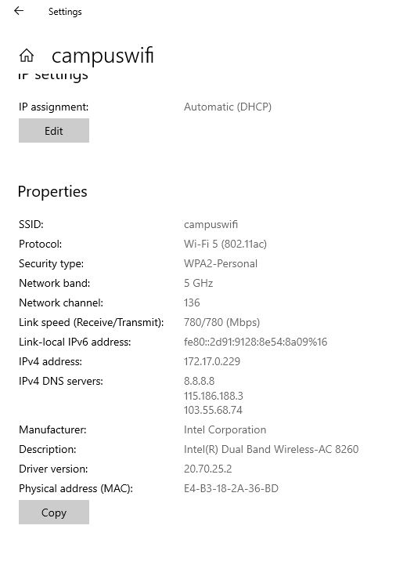

5:

* Simply open Window PowerShell
* Type gip

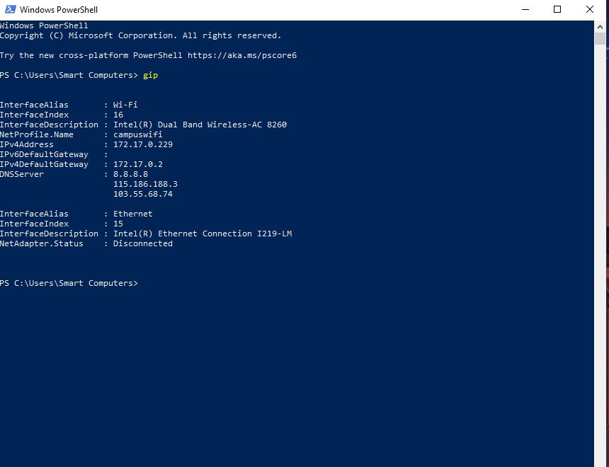

6:

Open Windows PowerShell

* Type Get-NetIPConfiguration

